Discrete Random Variables and the Binomial Distribution

Consider a dice with the following information:

X = Output 1 with the probability of 1/2

X = Output 2 with the probability of 1/3

X = Output 3 with the probability of 1/6

Hence, E(X) = ∑ x.P(x)
x є X

E(X) = 1.(1/2) + 2.(1/3) + 3(1/6) = 1 + 2/3 = 5/3

Thus, any variable that has probabilities of equaling different values is a discrete random variable. We calculate the average or expected value of that discrete random variable using the formula above. As an exercise, let Y be the discrete random variable equal to the sum of the faces after rolling two standard six-sided dice. Show that E(Y) = 7.

In addition to expectation, we define a term called variance for discrete random variables. (This calculation is rarely made in computer science for algorithm analysis, but I am including it for completeness sake with respect to the topic of discrete random variables.) Variance is simply a definition which roughly gauges, "how spread out" the distribution of the discrete random variable is. Here is the formula:

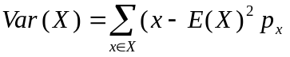

For our example above, we have

Also, the standard deviation of a discrete random variable is simply defined as the square root of its variance. An alternate way to calculate variance is as follows:

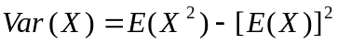

We define E(X²) as follows: 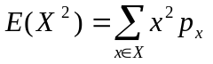

In the text, a proof is given for the result for the alternate calculation of variance. This is Theorem 3.12.

Binomial Probability Distribution

If we run n trials, where the probability of success for each single trial is p, what is the probability of exactly k successes?

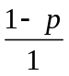 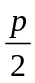 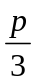 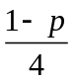 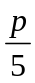 ……. 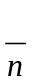

k slots where prob. success is , n-k slots where prob. failure is 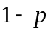

Thus, the probability of obtaining a specific configuration as denoted above is p^{k}(1-p)^{n-k}. From here, we must ask ourselves, how many configurations lead to exactly k successes. The answer to this question is simply, "the number of ways to choose k slots out of the n slots above. This is 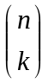. Thus, we must add p^{k}(1-p)^{n-k} with itself exactly times.

This leads to the following answer to the given question:

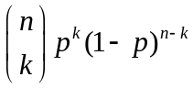

We can also define a discrete random variable based on a binomial distribution. We can simply allow the variable to equal the number of successes of running a binomial trial n times. We then separately calculate the probability of obtaining 0 successes, 1 success, etc. , n successes. Here is a concrete example with n = 3 and p = 1/3:

X = 0, with probability 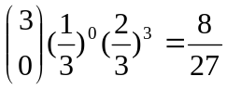
X = 1, with probability 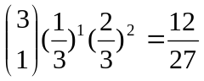
X = 2, with probability 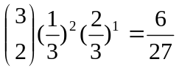
X = 3, with probability 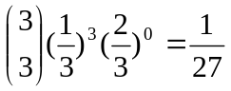

We can calculate that E(X) = 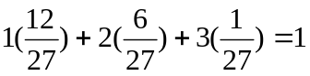.

Why can we leave at the term when X = 0? Also, why is this value in tune with our intuitive idea of what we should expect? We can formally prove this intuitive notion, namely that for a binomial distribution X, E(X) = np. The proof is Theorem 3.11 in the text.

